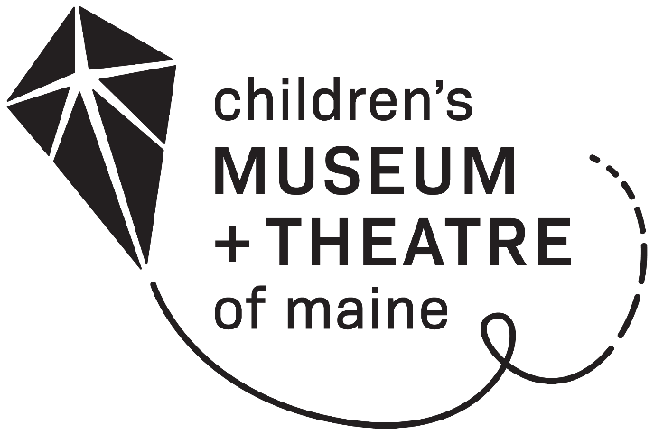
NON-PROFIT
MEMBERSHIP

A Children’s Museum & Theatre of Maine membership program for non-profit organizations and their patrons.
Limit one per organization.

COST: $250 for a one-year membership

BENEFITS:

- Free general admission for up to six people per day
- Additional visitors receive a discounted group admission rate
- A sign for your front desk or bulletin board
- A calendar to keep track of when your pass is checked out

TO APPLY:

Contact Person: ___________________________ Contact Phone: ______________

Contact Email: _______________________________________________________

Organization Name: ____________________________________________________

Organization Address: ___________________________________________________

Organization Phone: ____________________________________________________

Name of Organization as you would like it to appear on membership (If different from above):

_________________________________________________________________________

Please return form, payment and IRS 501(c)(3) letter to:
Children’s Museum & Theatre of Maine
250 Thompson’s Point Road
Portland ME 04102

To sign-up or renew via phone, please call (207) 828-1234 x290.

Non-Profit Membership Policies

- A non-profit pass entitles the holder to free Museum admission to the Children's Museum & Theatre of Maine for up to 6 people per day. The pass may only be used once per day. Each additional visitor will be charged the guided group rate of $8.50 per person.

- To use the pass, members must present a photocopy of the pass itself placed on the guideline sheet. The pass should be placed so that the membership information (organization name, membership expiration date, etc.) is visible.

- The pass must be signed by an authorized representative of the organization and dated with the date of intended use.

- The pass is valid when the Museum & Theatre is open to the public.

- Visitors using the pass are welcome to attend any and all programs that are free with admission. The pass is not valid for theatre productions or paid programs and does not entitle the holder to members-only events or benefits.

- If you’d like to bring a group of ten or more visitors to the Museum with your membership, please call 828-1234 x290 at least 24 hours in advance to reserve your space.

